**Power Season 7: Release Date and other details!** 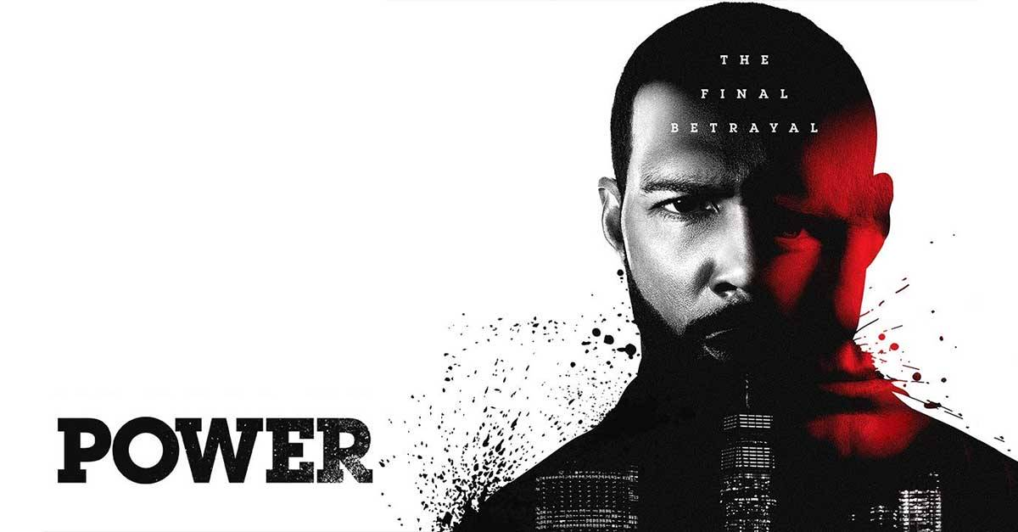

**Power**, an **American crime drama television series** created by **Courtney A. Kemp** and distributed by **Starz Media**. It's one of the highest-rated series of **Starz**. It's nominated several times for many awards and even won many and received so many positive reviews from the audience, so a huge fan base is waiting for another season of Power. So, let's see if there'll be any release of another **season**.

**Power Season 7: Release Date**

**Power** was released for the first time on June 7, 2014, and the last **episode** aired on February 9, **2020**. **Power Season** 1 premiered on June 7, 2014, to August 2, 2014. **Power Season** 2 premiered on June 6, 2015, to August 15, 2015. **Power Season** 3 premiered from July 17, 2016, to September 25, 2016. **Season** 4 aired from June 25, 2017, to September 3, 2017. **Season** 5 aired from July 1, 2018, to September 9, 2018. Then **Season** 6 streamed from August 25, 2019, to February 9, **2020**. According to the sources, Season 6 was the last and final season of Power. The creators and distributors of the series announced the renewal of **Power Season** 6 as the last and final **season** of the **series**. But there's some good news for the fans too, the creators of the series announced that they'll create 4 spin-offs that will have the same actors and characters from the series. These spin-offs are **Power Book II: Ghost**, **Power Book III: Raising Kanan**, **Power Book IV: Force**, and **Power Book V: Influence**. The first spin-off of the series **Power Book II: Ghost** started its premiere on September 6, **202**0. Then, on August 31, **2020**, it was made official that the second spin-off Power Book III: Raising Kanan will begin its premiere in the summer of **2021**. So now it depends on the creator when they're willing to release the same. There's no more official announcement on the same.

**Power Season 7: Probable Cast**

As announced by the creators that there'll be spin-offs comprising of the characters and the actors from the series **Power**. So, it's highly likely that we're going to see the actors repeating their roles in the incoming spin-offs. Additionally, there may be few more characters but nothing has been announced as of yet. So, lets' recap a few characters who appeared in the previous **seasons** and are likely to appear in the spin-offs either as living or dead in the form of flashbacks.

**James " Ghost" St. Patrick** played by Omari Hardwick- He's a high-level **drug distributor** who owns a nightclub. He's Tasha's husband and he's romantically attached to Ausa Angela Valdez.

Thomas "Tommy" Egan played by Joseph Sikora- He's James's best friend and he takes care of his children properly. He is very respected in the family. 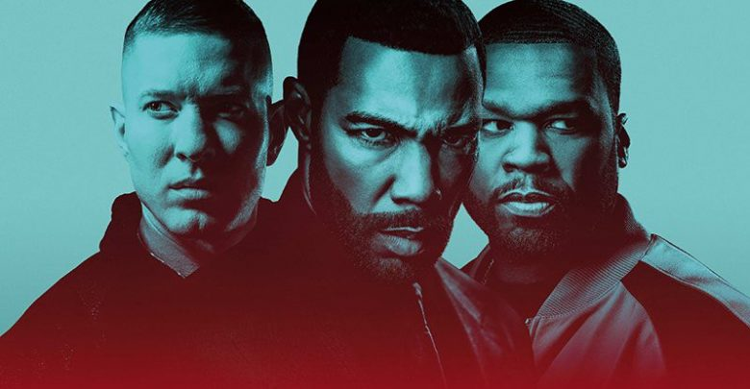

**Angela Valdes** played by Lela Loren- She's an assistant US attorney, who's given the task of Ghost's prosecution. She's Ghost's love interest. She went to the same high school as Ghost and Egan.

**Tasha St. Patrick** played by Naturi Naughton- She's Ghost's ex-wife. She has a love interest in Terry Silver and Shawn. She's Q's love interest too.

Kanan Stark played by Curtis Jackson- He's a drug dealer who's trapped by **Ghost** and his ex-wife *Tasha* to be imprisoned for 10 years.

Tariq James St. Patrick played by Michael Rainey Jr.- He's **Ghost** and Tasha's son. He's having a bad relationship with his father because of Ghost's relationship with *Angela Valdes* and him lying about his involvement in the drug dealing. He has two sisters Ray and Yasmine. Ray's murdered by a police officer when she's caught being involved in a home invasion robbery.

Lakeisha Grant played by La La Anthony- She's *Tasha*'s friend who's a hairstylist and owns a business. She's Tommy's love interest.

Andre "Dre" Coleman is played by Rotimi Akinosho- He's also a drug dealer who works with *Ghost* and Kanan.

And many others.

**Power Season 7: Expected Plot**

**Power** revolves around drug dealing. It depicts the story of Patrick who's a wise drug dealer who's not willing to continue the drug dealing and he wants to be in the club operation sector. He wishes to fulfill his while saving himself from the police and trying to save his marriage life. Few expectations from the upcoming spin-offs are:

Cash will come back to take vengeance against *Tasha* and kill her for sabotaging her mother.

*Angela* was likely to kill her boyfriend Greg but according to the sources, the script is changed and she's murdered.

There might be a possibility that *Ghost* faked his death.

*Tasha* could've unconsciously revealed that *Tariq* was the one who pulled the trigger then why did she name *Tommy*.

There's a possibility that *Tariq* will hand himself under pressure. And many other character roles are yet unwrapped which can be taken in the spin-offs.

**Trailer** for **Power Book III: Raising Kanan** has been released on December 27, **2020**, by **Starz Media**. And this spin-off is likely to be released by the summers of 2021 till that time you can enjoy its **trailer**😊

https://www.youtube.com/watch?v=UxRuWH4hEb0